Contents

Introduction of analysis 3

1 Analysis methodologies 3

2 Information gathering 6

3 Feasibility study 6

4 Software Requirements Specification 7

4.1 Hardware and software 7

4.2 Functional requirement 7

4.3 Non-Functional requirements 9

4.4 MoSCoW 10

5 Use Case Diagram 12

5 System architecture 14

3 tier architecture 18

References 19

# Introduction of analysis

Analysis is the method of breaking down a something into its parts to learn what they do and how they relate to one another. Analysis we can know about the problem and helps to make the decision.

In my project with helps of analysis it will helps which analysis methodologies is best for my project. It also show the feasibility of my project. With the help of the analysis I can gather information about the requirements by interview, groups focus, questionnaires to user. After gathering the requirements I can make decisions which features is must have in the project and other features will be should have, could have and won’t have. In analysis I can know about which hardware and software is gone use in the project. Through analysis I can separated functional and non-functional of the project. In analysis it show use case diagram to show how system will work.

By this way analysis play vital role in my project. With analysis I can make decision for my project by choosing the methodologies gathering requirements which requirements is most importance for the project so I can give more time on that requirement.

# 1 Analysis methodologies

A methodology offers a structure to follow when working on a project and makes the analysis and design more manageable. For this I choose hard systems methodology. In hard system methodology focuses on technical part of the system. In hard system methodology I did Structured Systems Analysis and Design Method. The reason are:

* This is waterfall method for analysis of the information system.
* It use Logical data modeling
* It use Data Flow Modeling
* It use Entity Event Modeling
* It ensures thorough planning and scheduling

**Data flow diagram**

A data flow diagram (DFD) illustrates how data is processed by a system in terms of inputs and outputs. As its name indicates its focus is on the flow of information, where data comes from, where it goes and how it gets stored. (Anon., 2011)

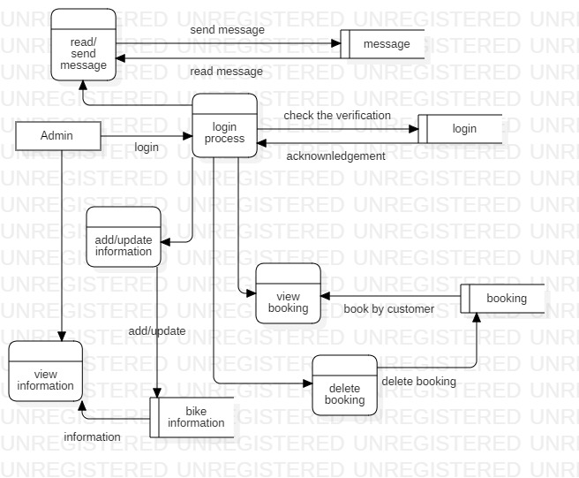

Figure 1: admin data flow diagram

This is admin data flow diagram. In here we can see firstly admin login then it check it verified or not then after it verified admin can add/update the information, view the booking and delete the booking, read and send message to customer. To view the information about bike admin does need login.

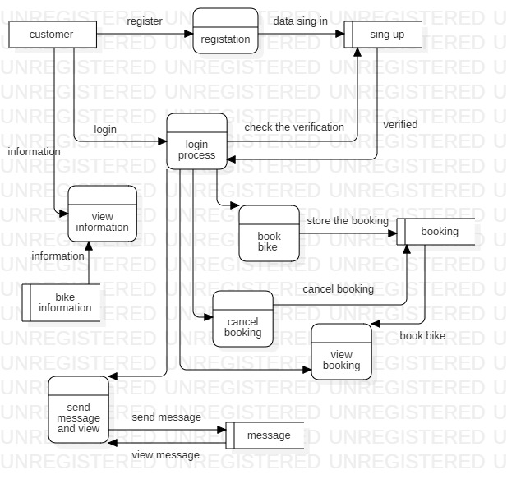

Figure 2: customer data flow diagram

In this figure firstly customer have to register of the customer is ready register then customer can login. In here also customer does not have to login to view the information about bike. After login customer can book the bike, view booking, cancel the booking. Customer can send message to admin and view message to admin.

In figure 1 and 2 we can see how data is process and store in database.

# 2 Information gathering

User are the main source of the information in the project. Through the user we can know the problem and requirements of the project. By taking information we make solution of the problem. For the information gathering I have interview the staff of the organization. After interviewing them I find out that about eighty percent of staff is not happy with this manual system in organization. Main problem is the customer does not know what are the paper is need for booking, and also to find the location of the organization. Customer does not know what type of the bike available in the organization. About ten percent does not have the problem and other ten percent is neutral. Through the interview I have gather information which will to make successful project. To make successful project I have make the website which in where all information about bike. And what kind paper is need to book the bike and it should also have the location of the organization.

# 3 Feasibility study

Feasibility study is an evaluation and analysis of the potential impact of a proposed project. With help of feasibility study I can find out my project is sufficient for development by technical, economical, time, legal and social. The reason are.

* **Technical:** This small project all hardware and software need for this project are easily available in market. This website can run in mobile also from any place world booking can be done. In technical this project is feasibility.
* **Economical:** For this project all the software is used are open source. Hardware is also available. And collage project. So economical this project can be done without any problem.
* **Time:** To complete this project we have time of six months. In six months we can do analysis, designs, coding and testing, maintenance. Within time I can complete the task.
* **Legal:** This collage project so there will no copyright issue in the project. This is legal project.
* **Social:** This website can used by everyone. Anyone can book the bike and view the information.

# 4 Software Requirements Specification

Software requirements specification show the functional and non-functional requirements. It also show the interaction between customer and the system through the use care diagram. So it is importance in analysis cause it description of the functional and non-functional requirements of the software.

## 4.1 Hardware and software

Hardware and software give the information about the hardware and software used to develop the system

**Hardware**

* This system is develop in Dell inspiron 15 3000 series
* This system can run any hardware if change are require.

**Software**

* Software need to develop is Xampp because programming language written in PHP
* Xampp is cross platform it can run in windows, Linux and Mac.

## 4.2 Functional requirement

Functional requirement is that requirement which is need to run the system without this requirement system can’t be complete. So this are the functional requirements of the system

|  |  |  |  |  |
| --- | --- | --- | --- | --- |
| **ID** | **Title** | **Description** | **Rational** | **Dependencies** |
| F001 | Registration | User can register and login for booking | Without registration user can’t book. | NA |
| F002 | Login | In login user can book and send message and admin can read message | Without login other feature can’t be use to use the other feature login is needed | F001 |
| F003 | View bike information | User can view details of the bike available in company | After looking detail of the bike customer can book bike as their wish | NA |
| F004 | Book bike | Customer can book the bike available is company | After booking customer can rent the bike | F001, F003 |
| F005 | Add and update bike information | Admin can add and update information of the bike | if bike information is wrong enter then admin and update book and add new information about bike | F001 |
| F006 | Cancel booking | User can cancel the booking | If user has book wrong bike and user can cancel the booking | F001, F004 |
| F007 | Delete booking | Admin can delete the booking of the user | If user cancel the booking them admin can delete the booking | F001, F004, F006 |
| F008 | Send message | User and admin can communicate each other | If user find any problem or does not understand requirement user can message the admin | F001 |
| F009 | Read message | User and admin can read message each other | After message is send user and admin can read message then replay. | F008 |
| F0010 | Online payment | After booking user can send the payment through bank | To the money | NA |
| F0011 | Refund | After payment has done customer can get refund | If customer cancel the booking payment has done then they will gets their refund | F009 |
| F0012 | Delivery bike | To delivery the bike. | After bike is booked bike can delivery in user location | F004 |
| F0013 | Exchange bike | To exchange the bike rental | User can exchange the bike | F004 |
| F0014 | Location | It have the location of the company | User can easily find the place the location is provided | NA |
| F0015 | User can delete | User can delete the account | If user does not want to use this system they can delete their account | F001 |
| F0016 | Add admin | Admin can add other admin as well | Alone admin may not handle the detail of the system so they can add other admin | F002 |
| F0017 | delete account | Admin can delete the account | Admin can delete account of the add new admin | F0016 |

*Table1: functional table*

# 

## 4.3 Non-Functional requirements

Non-functional requirement means that system can run without it but if this functional is add then it will good.

There are some non-functional requirements.

|  |  |  |
| --- | --- | --- |
| **ID** | **Title** | **Description** |
| NF001 | Security | In security only valid user can use the system. To do that user authenticated is needed |
| NF002 | Usability | The system should be ease learn and satisfaction content of the use. |
| NF003 | Reliability | In here we look how to protect the failure to make trustworthy system. |
| NF004 | Maintainability | If in system need in any modification then modification should be done easily. |
| NF005 | Performance | System should response in time. It should perform in real time speed. |
| NF006 | Implementation | System must run in any browser from customer/client. No other things need to installation is needed |
| NF007 | Interface | It is part of interact. So inter face should be in web based. |
| NF008 | Legal | User data must be private. |

*Table2: non- functional table*

## 4.4 MoSCoW

MoSCOW stand for

M=Must haves in system

S= Should haves in the system

C=Could haves in the system

W= Won't haves in the system

With the help of the MoSCow I can complete the task in time. By using I will know which function have to done first and focus on the function. I should focus in must haves. Here are the list of the function and which are MoSCoW

|  |  |  |  |
| --- | --- | --- | --- |
| **ID** | **Requirement** | **MoSCoW** | **Rational** |
| F001 | Registration | M | To use the system |
| F002 | Login | M | To use feature of the system |
| F003 | View bike information | M | To provide the detail of the bike |
| F004 | Book bike | M | Fundamental function of system |
| F005 | Add and update bike information | M | Provide system add new details |
| F006 | Cancel booking | M | Provide the cancel booking for user |
| F007 | Delete booking | M | Provide to delete  the booking to admin |
| F008 | Send message | M | Provide the communication |
| F009 | Read message | M | after message is send it must be to read |
| F0010 | Online payment | W | User can pay after receiving the bike |
| F0011 | Refund | W | Payment is in won’t have so there will be no refund |
| F0012 | Delivery bike | W | Customer have to come themselves to receive |
| F0013 | Exchange bike | W | User can exchanges the bike |
| F0014 | Location | M | Provide the location of the company |
| F0015 | User can delete | C | To use the feature of the system |
| F0016 | Add admin | S | Function of the admin |
| F0017 | Delete account | S | Function of the admin |
| NF001 | Security | M | In system it is foundation function |
| NF002 | Usability | M | In system it is foundation function |
| NF003 | Reliability | M | In system it is foundation function |
| NF004 | Maintainability | M | In system it is foundation function |
| NF005 | Performance | M | In system it is foundation function |
| NF006 | Implementation | M | In system it is foundation function |
| NF007 | Interface | M | In system it is foundation function |
| NF008 | Legal | M | In system it is foundation function |

*Table3: MoSCoW table*

# 5 Use Case Diagram

Use case diagram show interact of system and user.

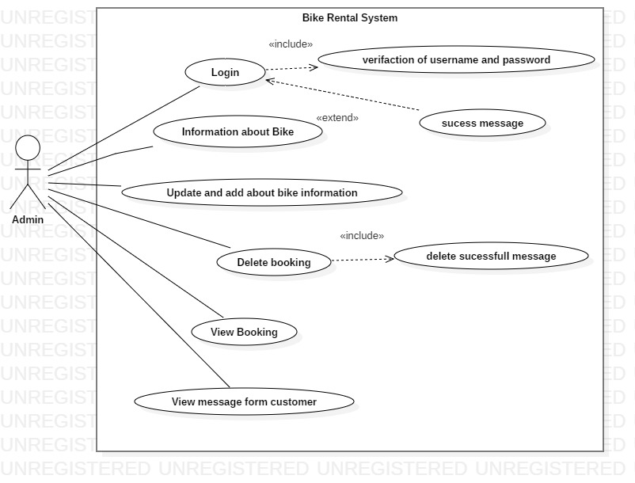

Figure 3: admin user case diagram

This is use case diagram of admin is the primary actor. In here we can see how admin interact with the system. Admin have login in the system to add and update the bike information, delete the booking, view the booking and view the message for customer.

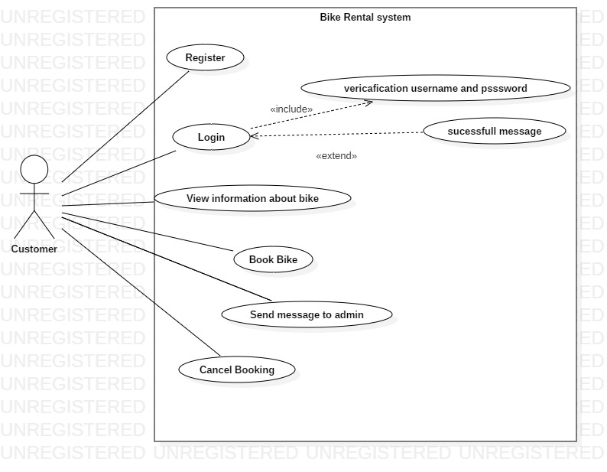

Figure 4: customer user case diagram

In this figure customer is the primary actor. As we ac seen in this figure first register have then customer can login to book the bike the send the message to admin and cancel the booking.

# 5 System architecture

The systems architect is a professional figure in information and communications technology. In system architecture I have done class diagram to class I have to follow the NLA (Natural Language Analysis) steps to do NLA I have create the scenario.

**Scenario**

Everest bike hire the company based in Kathmandu, Nepal. The company is established in 2014. The company provide the service to rent the bike.

So the company want to create their own website for customer where they can book the bike the view details of the bike, can message to the admin and have location of the company.

Customer can register and login allow then to book the bike, cancel the booking view the booking send and read message.

And admin can add the other user and add/update the bike information view the booking view the message form the customer and delete the booking.

**Natural Language Analysis (NLA)**

Natural Language Analysis (NLA) is to find the nouns, verb and adjectives from the descriptive text. With helps of NLA we can *find* candidate class, attribute and their relationship.

**The step of the NLA**

**List of the nouns**

Everest, bike, hire, company, information, company, rent, bike, company, customer, booking, bike, details, bike, message, location, company, bike, message, bike, booking, customer, message, booking, admin

**List of the verbs**

Create, add, update, book, register, login, book, add, update, cancel, delete, add, delete.

**Steps 1: Removing in repetition in nouns and verbs**

**Nouns**

Bike, company, customer, booking, details, message

**Verbs**

Add, delete, book, update

**Steps 2: Removing synonyms nouns / verbs**

**Nouns**

Rent, information

**Verbs**

Non available

**Steps 3: removing the nouns which does not have specific meaning**

**Nouns**

Everest

**Verbs**

Non available

**Steps 4 Remove out of scope**

**Nouns**

Company

**Verbs**

Non available

|  |  |  |  |
| --- | --- | --- | --- |
| **SN** | **Noun identification for the class** | **Selected as class** | **Justification of selection and rejection for the class** |
| 1 | Bike | Yes | They will many bike |
| 2 | Hire | Yes | It is fundament class |
| 3 | Book | Yes | It is fundament class |
| 4 | Location | No | Does not give any meaning |
| 5 | Details | No | Does not give any meaning |
| 6 | Customer | Yes | It is fundament class |
| 7 | Admin | NO | Does not give any meaning |

*Table 4: selection class table*

|  |  |  |  |
| --- | --- | --- | --- |
| **SN** | **Identification of verb** | **Use as method** | **description** |
| 1 | Add | NO |  |
| 2 | Create | Yes | Allow to create user |
| 3 | Delete | Yes | Allow to delete |
| 4 | Login | No | There is create |
| 5 | Register | No | There is create |
| 6 | Update | Yes | Allow to update data |
| 7 | Cancel | Yes | Allow to cancel |

*Table5: verbs table*

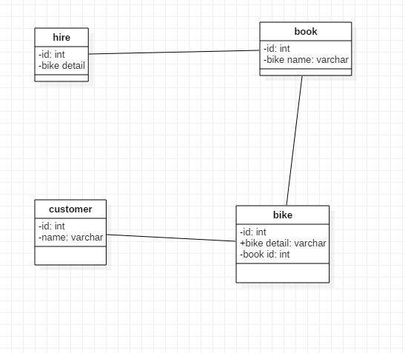

Figure 5: initial class diagram

This is class diagram. In this figure classes are only association with each other and few attribute. While doing task class relation can be change so they only associated now. In my project this kind classes.

## 3 tier architecture

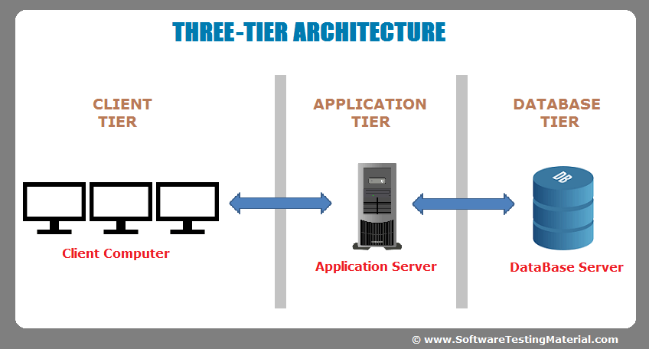

Figure 6: three tier architecture

For the system architecture I have choose three tire architecture. The reason the why I choose three tier architecture:

* There are unlimited client and they access from anytime and anywhere from the world. So there will no problem in scalability.
* It more secure because client will not does not interact directly with database. All data from will process in application server first then it will go to database.

# References

Anon., 2011. *data flow.* [Online]   
Available at: https://www.smartdraw.com/data-flow-diagram/  
[Accessed 2011].